 

**Hochschule Flensburg Wind Energy Technology Institude**

University of Applied Science Research on wind Energy

**Wind Farm Project in Gujarat, India**

**Wind Farm Project Development, WiSe 2024/25**

Master’s degree in Wind Engineering, Flensburg, Germany

**Submitted by**

Karan Soni (760153)

Mozafary Mostafa (750247)

Patil Rahul (750532)

**Supervising Professors:**

Prof. Marina Blohm

(Europa-Universität Flensburg)

**Date of submission:**

26.01.2025

Table of Contents

List of Figures v

List of Tables vi

Declaration on Report vii

Acronyms viii

1. Abstract 1

2. Introduction 2

2.1 Wind Energy in India 2

2.2 Importance of Wind Energy in Gujarat 2

2.3 Objectives of the Report 3

3. Literature Review 4

3.1 Wind Resource Assessment of Gujarat 4

3.2 Review of existing wind energy projects. 4

3.2.1 Scaling challenges in Gujarat 4

3.2.2 Suzlon secures a repeat order of 193.2 MW in Gujarat 4

4. Methodology 5

5. Legal Framework 6

5.1 Regional Planning Requirement 6

5.2 Guidelines for Micro siting of wind turbines (MNRE) 6

5.3 Law & Regulation as well as Park Layout 7

5.3.1 Consent to Establish (CTE) from Gujarat State Pollution Control Board (GPCB) 7

5.3.2 Permission from Forest Department 8

5.4 Eco-sensitive zones 9

5.5 NOC from Airports Authority of India (AAI) and Ministry of Defence 10

5.6 No Objection Certificate (NOC) from State Electricity Board 10

5.7 Land Allotment Letter 11

5.8 NOC from Mining Department 11

5.9 NOC from Village Panchayat 11

5.10 Power Purchase Agreement (PPA) 11

6. Wind Farm Development 12

6.1 Wind Area Selection 12

6.1.1 Steps Involved in the QGIS: 12

6.1.2 Steps Involved in the Earth Pro: 14

6.1.3 Steps Involved in the Wind Pro: 16

6.2 Electrical Grid Infrastructure and Cable Routing: Ensuring Connectivity 16

6.3 Turbine Components: Logistics and Transformation 17

6.4 Biodiversity Impact: 20

7. Community Engagement: Strategies for Local Acceptance 22

7.1 Stability of the power grid: 22

7.2 Improvement to infrastructure: 22

7.3 profit-sharing for landowners: 23

7.4 General strategies: 23

8. Land Leasing and Acquisition: Securing the Site 25

8.1 Lease Duration and Terms 25

8.2 Eligibility and Allocation 25

8.3 Application and Approval Process 25

8.3.1 Government land Approval Process: 26

8.3.2 Private land Approval Process: 27

8.4 Usage and Compliance 28

8.5 Financial and Operational Responsibilities 28

8.6 Governance and Oversight 28

8.7 Provision of Land procurement/ acquisition in Gujarat Wind Power Policy 2016 29

9. Addressing Conflicting Interests 30

10. Economic analysis 32

10.1 Profitability Analysis: Calculating the Financial Viability 32

10.2 Results 34

11. Project Development Timeline 35

12. Barriers and Obstacles to Wind Farm Development 36

13. Long-term Strategy: Wind Energy Development Roadmap to 2030/2050 37

14. Conclusion: 38

References i

Appendices v

Park Calculation Report: v

Income Statement of the Wind Farm Project: vi

Income Vs Years: vii

Operating costs (OPEX) vs Years: vii

Debt service Vs Years: vii

Taxes Vs Years: viii

GitHub Link viii

# List of Figures

Figure 6. 1 Merged no-go area 13

Figure 6. 2 The merged wind speed into white map 13

Figure 6. 3: Selected wind farm area 14

Figure 6. 4: Wind area, available substation and present installed wind turbines [16] 14

Figure 6. 5: Type of land and soil at WTG location 15

Figure 6. 6: Elevation profile in wind farm area 15

Figure 6. 7 Wind rose 16

Figure 6. 8 Wind farm area with wind turbine 16

Figure 6. 9: Substation and Cable routing plan 17

Figure 6. 10: Routes for transporting wind turbine components 18

Figure 6. 11: Routes for transporting wind turbine components from Highway to Wind Farm Area 19

Figure 6. 12: The flight corridor of lesser floricans in Gujarat **Invalid source specified.** 20

Figure 6. 13: The margin distance between wind farm to the Lesser flight corridor 21

Figure 7. 1: Table of power outage schedules in the state of Gujarat, India 22

Figure 8. 1: Government land approval process for wind farm [13] 26

# List of Tables

Table 2. 1: Potential of Energy in Gujarat, India [1] 2

Table 5. 1: Forest Clearance Procedure [9] 8

Table 6. 1: Specify buffer distances for each feature as per the project guidelines 12

Table 6. 2: Suzlon wind turbine manufacturing component’s locations and distance from wind farm [17] 18

Table 7. 1: The proposed rates, including a fixed amount and a flexible amount 23

Table 8. 1: Project registration [19] 29

Table 9. 1: Addressing Conflicting Interest 31

Table 10. 1: Economics of A Typical Wind Farm 34

Table 10. 2: Results 34

Table 11. 1: Project development timeline [18] 35

# Declaration on Report

We hereby declare that we, **Karan Soni, Mozafary Mostafa, and Patil Rahul**, have together written the submitted paper. We did not use any outside support except for the quoted literature and other sources mentioned in the paper. We have clearly marked and separately listed all the literature and other sources we employed when producing this academic work, either literally or in content. This report has not been submitted or published before in the same or similar form.

Flensburg, 26.01.2025 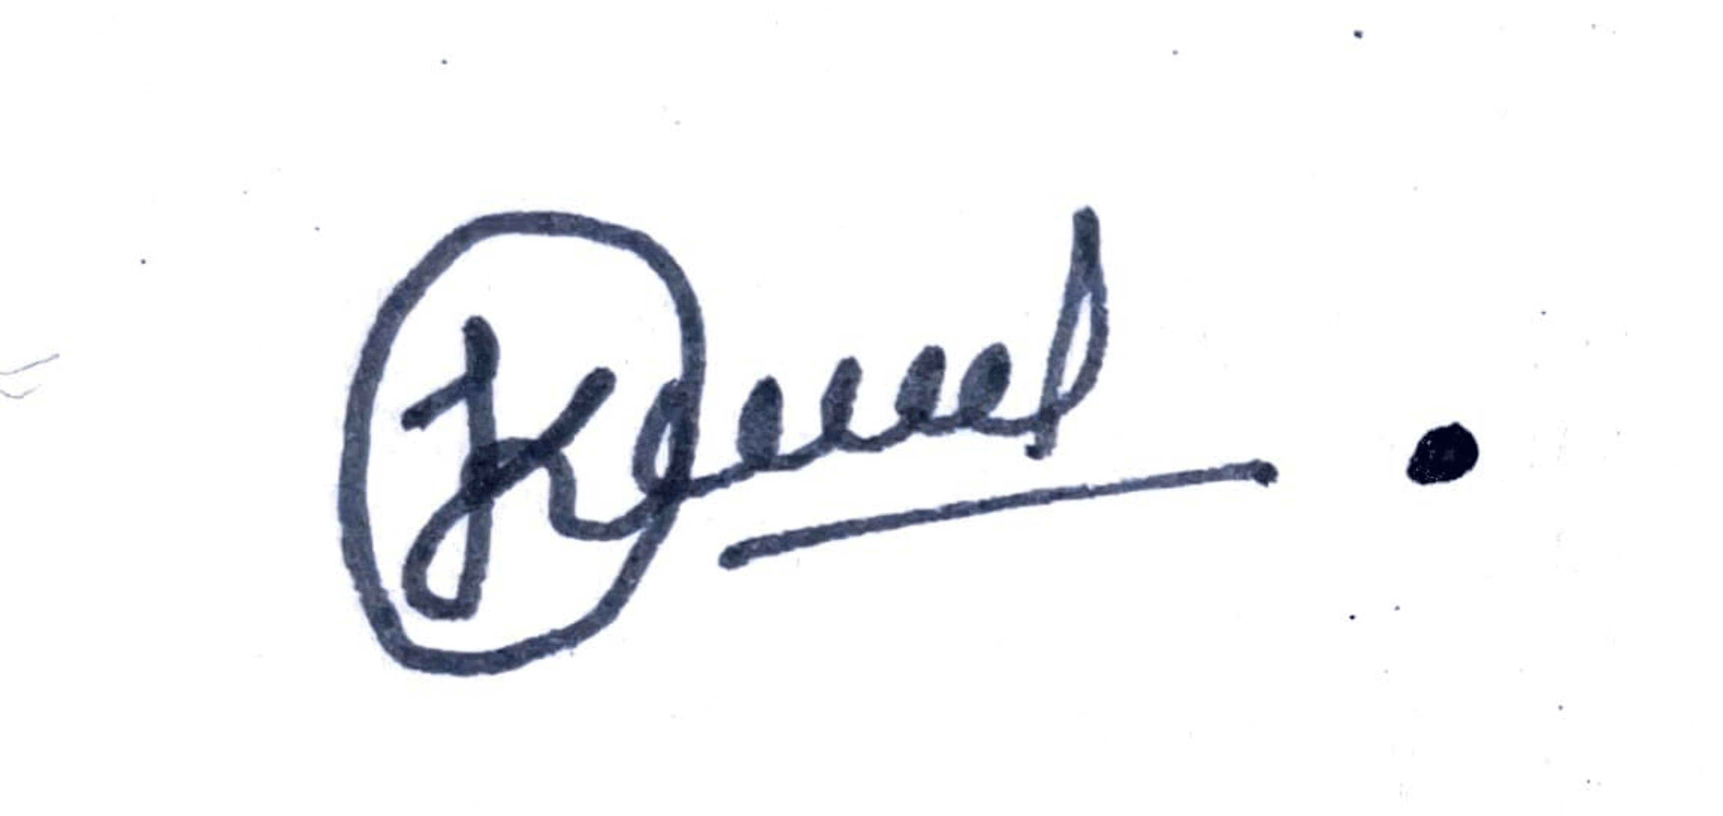

Place, Date Karan Soni



Flensburg, 26.01.2025

Place, Date Mozafary Mostafa



Flensburg, 26.01.2025

Place, Date Patil Rahul

# Acronyms

CAPEX Capital Expenditure

OPEX Operating Expenditure

QGIS Quantum Geographic Information System

NPV Net Present Value

IRR Internal Rate of Return

LEC Levelized Cost of Energy

Min. DSCR Minimum Debt Service Coverage Ratio

ADSCR Average Debt Service Coverage Ratio

CUF Capacity Utilization Factor

DFIG Double Fed Induction Generator

WTG Wind turbine Generator

IEC International Electrotechnical Commission

EHV Extra High Voltage Lines

CTE Consent to Establish

CTO Consent to Operator

MoEF Ministry of Environment and Forest

MoEFCC Ministry of Environment, Forest and Climate Change

NBWL National Board for Wildlife

AAI Airports Authority of India

CCZMs Colour Coded Zoning Maps

IAF India AirForce

LMAs Local Municipal Authorities

NOC No Objective Certificate

AGL Above ground Level

DLIR District Level Industrial and Revenue

PPA Power Purchase Agreement

CRS Coordinate Reference System

GPCL Gujarat Power Corporation Limited

ATS Agreement to Sell

NA Non-Agricultural

GST Goods and Services Tax

HPC High Power Committee

GEDA Gujarat Energy Development Agency

ACS Additional Chief Secretary

PS Principal Secretary

CCD Climate Change Department

AS Additional Secretary

JS Joint Secretary

EPD Energy and Petrochemicals Department

GUVNL Gujarat Urja Vikas Nigam Limited

REC Renewable Energy Certificate

EBITDA Earnings before Interest, Taxes, Depreciation and Amortization

EBIT Earnings before Interest, Taxes

EBT Earnings before Taxes

HH Hub Height

RD Rotor Radius

D Dimeter

m meter

Km Kilo meter

MW Megawatt

kV Kilo Volt

kwh kilo watt hours

# Abstract

This report presents general information on wind farm development in Poladia, Bhuj, Gujarat, India. The project was developed as part of the “Wind Farm Project Development” module within the Wind Energy Engineering Master’s Program at the University of Applied Sciences in Flensburg.

The report discusses the legal requirement and procedure for development of wind farm specific in Gujarat. Subsequently, it considers the installation of **six (2.1 MW)** wind turbines from Suzlon and details the wind farm layout, total energy yield, and the calculation of CAPEX and OPEX. The analysis uses three main software tools: QGIS, Earth Pro and Wind Pro.

The selection of Suzlon turbines is justified based on their efficiency, reliability, and suitability for the region. The report also addresses regulatory, environmental, and logistical challenges encountered during development and highlights the project's alignment with Gujarat's renewable energy goals and India's wind energy roadmap.

This study evaluates the financial viability of the project, revealing a positive NPV of **3,03,893** **Euros** and an IRR of **8.730%**, indicating profitability and return on investment. With a levelized cost of energy at **0.0179 Euros** and solid debt service coverage ratios, the project promises cost-efficiency and financial stability.

In the project, there was also a discussion about the barriers and obstacles, and how strategies were developed to overcome them. Overall, the Poladia wind farm project showcases a successful integration of advanced engineering, strategic planning, and financial stability, setting a benchmark for future renewable energy projects in India.

# Introduction

This chapter explains the wind energy potential in India specifically in Gujarat as well as include objectives of the project.

## 2.1 Wind Energy in India

India has made significant wind energy farm over the past few decades, becoming Globally, India ranks **4Th** in terms of installed wind power capacity. The journey began in the **1980s** with small-scale wind energy projects. The first wind farm was established in **1986** in coastal Gujarat. India has developed several large wind farms, particularly in states like Gujarat, Tamil Nadu and Maharashtra. India's growing energy demand, driven by its development, necessitates diversifying energy sources with a focus on sustainability. Wind energy plays a crucial role in this strategy, with a high-wind potential of **695 GW** at **32%** CUF (**130-meter** hub height). To leverage this, India aims to expand wind energy capacity from the current **48 GW** to **140 GW** by 2030, highlighting its commitment to energy security and sustainable development. [1] [2] [3]

## 2.2 Importance of Wind Energy in Gujarat

[As of **May 2024**, Gujarat has an impressive **11,823 MW** of installed wind power capacity](https://www.thehindubusinessline.com/economy/gujarat-bags-award-for-highest-wind-power-installed-capacity/article68292944.ece). [This makes it the leading state in India for wind energy, surpassing Tamil Nadu, which has **10,743 MW**](https://www.thehindubusinessline.com/economy/gujarat-bags-award-for-highest-wind-power-installed-capacity/article68292944.ece). [4] Its growth has been significantly influenced by a dedicated wind and land policy, which is further explored in a later section of this report.

|  |  |  |  |
| --- | --- | --- | --- |
| No | State | Wind Potential at 120 m (GW) | Wind Potential at 150 m (GW) |
| 1 | Andhra Pradesh | 70.90 | 123.3 |
| 2 | Gujarat | 142.56 | 180.8 |
| 3 | Karnataka | 124.15 | 169.3 |
| 4 | Madhya Pradesh | 15.40 | 55.4 |
| 5 | Maharashtra | 98.21 | 173.9 |
| 6 | Rajasthan | 127.75 | 284.2 |
| 7 | Tamil Nadu | 68.75 | 95.1 |
| 8 | Telangana | 24.83 | 54.7 |
| 9 | Other | 18.95 | 27.1 |

Table 2. 1: Potential of Energy in Gujarat, India [1]

## 2.3 Objectives of the Report

* To examine the policies and regulations that have supported the development of wind energy in Gujarat.
* Design and analyse of Wind Farm using GIS, Earth Pro and Wind Pro software.
* Estimate energy yield for wind turbine layout with wake losses and calculate economic analysis
* To identify the key drivers and barriers to the expansion of wind energy in Gujarat, India, including infrastructure, financing, and policy support.
* Making schedule and timetable for wind Farm development project in Gujarat, India.

Chapter 3 provides a comprehensive review of existing wind energy projects and the strategic methods used to overcome various challenges in Gujarat. Chapter 4 discusses the method used to achieve the objective. Chapter 5 outlines the key requirements and criteria for developing wind farms in Gujarat, encompassing regional planning, micro siting guidelines, legal regulations, eco-sensitive zones, and necessary permissions from various authorities. Chapter 6 explores the process of wind farm development, from site selection to infrastructure and logistics. Chapter 7 provides strategies for community engagement to ensure local acceptance of wind projects. Chapter 8 details the land leasing and acquisition process, including lease terms, eligibility, and approval procedures. Chapter 9 addresses conflicting interests and provides solutions to mitigate them. Chapter 10 conducts an economic analysis to evaluate the profitability and financial viability of wind projects. Chapter 11 presents a project development timeline. Chapter 12 discuss barriers and obstacles to wind farm development. Chapter 13 outlines a long-term strategy for wind energy development up to 2030 and 2050. Chapter 14 concludes with key findings and recommendations.

# Literature Review

## 3.1 Wind Resource Assessment of Gujarat

The wind resource estimates in this study highlight regions with average annual wind speeds above **8 m/s**, mainly in the Gulf of Kutch and the southern coast. Similar to past research in **2011** confirms the highest wind potential in the northwestern Gulf of Kutch, with comparable potential found along the southern coastline. While the International Renewable Energy Agency agrees on high wind speeds in these areas, they report higher speeds of **9 m/s** in the Gulf of Khambhat, exceeding our estimation. [5]

Wind speeds in Gujarat peak from May to August, reaching over **10 m/s**, particularly along the coast and the lowest in October and November, averaging below **7 m/s**. Gujarat has a tropical and subtropical steppe climate, with occasional cyclones, droughts, and floods. The state experiences three main seasons: winter (November-March), summer (March-June), and monsoon (June-September). The northern region is dry, while the southern part is humid, with coastal winds influenced by sea breezes. [5]

## 3.2 Review of existing wind energy projects.

### 3.2.1 Scaling challenges in Gujarat

Renewable energy development, particularly large-scale wind farms, faces multiple challenges (Land Acquisition and local engagement, Logistical Challenges, Grid Integration, Regulatory and Environmental Hurdles, Financial and Contractual Risks, Stakeholder Coordination) that can significantly impact project timelines, costs, and outcomes. The experiences of hypothetical projects like Adani Wind Energy’s **300 MW** wind farm in India’s coastal region highlight key obstacles.Successful wind energy projects, such as those proposed by Adani Wind Energy, provide valuable lessons for future initiatives in the renewable energy sector. [6]

### 3.2.2 Suzlon secures a repeat order of 193.2 MW in Gujarat

Suzlon Group has secured a repeat order from the KP Group for a wind energy project in Gujarat. This collaboration highlights the private sector's commitment to sustainable growth which is supported by Gujarat's favourable policy environment. Suzlon's advanced Double Fed Induction Generator (DFIG) technology enhances turbine performance and energy capture. The company's R&D focuses on optimizing energy efficiency and reducing costs. Suzlon’s domestically manufactured turbines contribute to India's self-reliance in the renewable energy sector, aligning with the "Aatmanirbhar Bharat" initiative. This partnership supports India's net-zero goals while promoting economic progress through clean energy. [7]

# Methodology

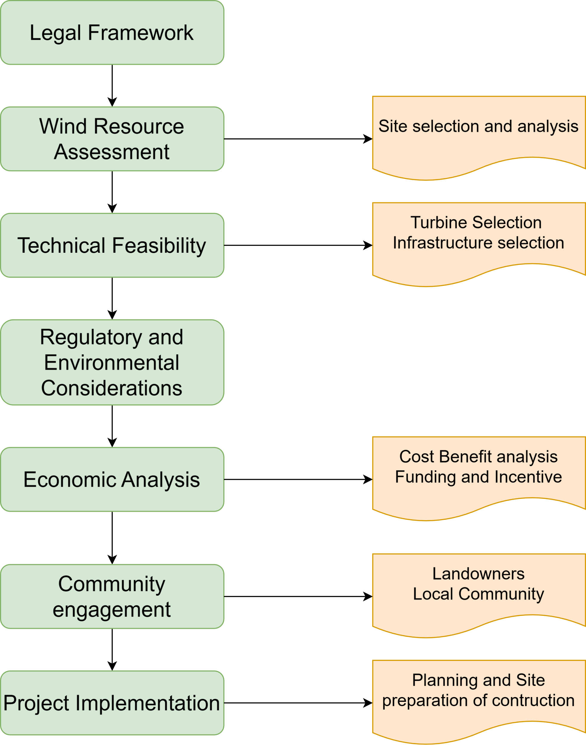

# Legal Framework

The chapter explains the key requirements and criteria for developing wind farms in Gujarat.

## 5.1 Regional Planning Requirement

To promote the healthy and structured growth of the wind power sector in India, the Ministry of New & Renewable Energy (MNRE) introduced guidelines for wind power project development in **July 1995**, which have been periodically updated (**Last updated 2024**). Considering advancements in technology, new regulations, and the need for accelerated growth in the sector, the MNRE has recognized the importance of issuing comprehensive guidelines for wind power project development in collaboration with various stakeholders.

The process of wind power project development starts with site selection. Identification of suitable sites depends upon land use permission, availability of wind resource, technically and commercially feasible grid connectivity, transport logistics and environmental acceptability.

* Land use permission
* Availability of wind resource
* Technically and commercially feasible grid connectivity
* Transport logistics
* Environmental acceptability

## 5.2 Guidelines for Micro siting of wind turbines (MNRE)

Micro siting is the optimization of energy production through the correct placement of wind turbine generators in the wind farm area, considering all physical constraints of the area.

Micro siting criteria are prescribed as under.

Developer(s) shall optimise the wind turbine locations within their land using appropriate wind flow modelling and optimisation tools (linear and Nonlinear)/techniques subject to site assessment as per **IEC 61400-1** standard for turbine safety considering extreme wind, flow inclination, vertical wind shear, and turbulence with added wake effects and corrections for terrain complexity etc.

Developer(s) shall maintain a distance of $2D$ (D-Rotor Diameter) distance perpendicular to the predominant wind direction and $3D$ distance in the predominant wind direction from the boundary line of each adjoining land of other developer(s) with appropriate offset.

Developer(s) shall maintain a wake loss (in terms of energy) of **10%** between wind turbines with appropriate offset for wind turbines sited on a footprint basis.

Developer(s) shall maintain a distance of $HH+0.5∙RD+5m$ (Hub Height+ Half Rotor Diameter +5 meters) from Public Roads, railway tracks, highways, buildings, public institutions and EHV lines.

Developer(s) shall not site wind turbines within **500 m** of any living places for the mitigation of noise. ‘dwelling’ shall mean at least **15** inhabited buildings. [8]

## 5.3 Law & Regulation as well as Park Layout

### 5.3.1 Consent to Establish (CTE) from Gujarat State Pollution Control Board (GPCB)

#### 5.3.1.1 Consent to Establish (CTE)

Required to obtain CTE under **section 21(1)** of the Air (prevention and control of pollution) **Act, 1981**. Also, CTE under **section 25/26** of the Water Act is required in case of discharge of sewage or trade effluent in a stream or a well or a sewer or a lake. [section 21(1) of the Air (prevention and control of pollution) Act, 1981]

#### 5.3.1.2 Consent to Operate (CTO)

Prior to commercial generation, it is obligatory to apply for CTO under **section 21** of the Air (P & CP) **Act 1981**, with respect to ambient air quality related to noise. [ section 21 of the Air (P & CP) Act 1981,]

#### 5.3.1.3 Apply for Hazardous Waste Authorisation

Wind power projects use different types of fluids for the smooth operation of the WTG. Primarily, three main types of fluid are used: First, Generator cooling fluid is used as coolant (a mixture of glycol and water, similar to what is used in automobile radiators). Second, Lubricating oil is used in the gearbox (synthetic oil). Third, Hydraulic oil for operating the blade pitch system, yaw mechanism and brakes. To protect transformers from heating, mineral oil (transformer oil) is used as coolant. [9]

### 5.3.2 Permission from Forest Department

Under **Rule 6** of the Forest (Conservation) **Rules, 2003**, any project that intends to use forest land for non-forest purposes must submit a proposal using the prescribed forms included in the rules. [10]

|  |  |  |  |
| --- | --- | --- | --- |
|  | Advising/ Recommending body | Route | Final clearance Authority |
| < 1 hectare | - | - | State Government (Principle Secretary of Forest) |
| 1 – 5 hectares | State forest department | State government to regional office of MoEF | Regional office MoEF |
| 5 – 40 hectares | State Advisory group | State Government to regional office of the MoEF; then to the MoEF with state advisory group recommendations | MoEF |
| > 40 hectares | Forest Advisory Committee | State government to MoEF | MoEF |

Table 5. 1: Forest Clearance Procedure [10]

The forest clearance process begins with the project proponent submitting an application to the nodal officer of the state forest department. The application is forwarded to the district-level field office, where an inspection of the proposed land is conducted. After this evaluation, the application is sent back through the forest department hierarchy to the Principal Secretary of Forests. The final approval authority depends on the extent of forest land to be diverted: the proposal may either be approved by the Regional Office of the Ministry of Environment, Forest, and Climate Change (MoEFCC) or by the Secretary, at the regional or central level, based on the project's scale and requirements. [10]

Further, the forest guidelines also specify certain criteria for the setting-up of a development project, which states that no projects should be in the vicinity of the following:

* National Parks, Wildlife Sanctuaries and Core areas of the Biosphere Reserves.
* Scenic landscapes, areas of geo-morphological significance, unique and representative biomes and eco-systems, heritage sites/structures and areas of cultural heritage and importance.
* Fragile eco-systems such as mountains; areas rich in coral formations as well as marine, coastal, desert, wetland, riverine and island eco-systems. Areas rich in biological diversity, gene pool and other natural resources.

## 5.4 Eco-sensitive zones

**In 2002**, the MoEF decreed that an area of **10 km** around national parks and sanctuaries should be assigned as an eco-sensitive zone, with restrictions on development.

Any project including wind power projects that fall inside the zone must seek approval from the National Board for Wildlife (NBWL). The NBWL may conduct a study if it believes the project may have large-scale impact.

**Wildlife Board’s guidelines on linear intrusion:**

* The guidelines are extensive and focus firstly on how to avoid the need for new roads and powerlines in natural areas. Only after avoidance is ruled out, do the guidelines go into details of how roads and powerlines should be built to minimize and mitigate damage.
* Keep construction phase as short as possible, avoid night-time work as it disturbs animals.
* When one linear intrusion has been made, new projects should align with it so as not to cause further destruction.
* According to the guidelines, roads should be no wider than **12.5 m** for primary roads and 8.5 m for secondary roads.
* To avoid electrocution of elephants from powerlines should be a minimum of **6.6 m** above ground on level terrain and a minimum of **9.1 m** above ground on steeper terrain.
* Maintaining **1.5 m** spacing between energized components, cover and insulate energised hardware, include reflectors and perch deterrents. Install underground cables. Monitor effectiveness of measures.
* Structures, such as retaining walls that can act as barriers to animal movement should not be installed along roads, especially in hilly terrain. [11]

## 5.5 NOC from Airports Authority of India (AAI) and Ministry of Defence

**Aircraft Act, 1934** empowers the Central Government to impose restriction on the construction of buildings and other structures within a radius of **20 Km** from ARP of all aerodromes.

No Wind Turbine Generators (WTGs) shall be installed up to **10 Km** from the Radar Antenna of all Static Air Defence Radars and up to 8 km from ATS Radar antenna/VOR.

**Colour Coded Zoning Maps (CCZMs):**

* CCZMs have been formulated for all IAF aerodromes and handed over to Local Municipal Authorities (LMAs). Area in the centre of CCZM of **4 Km** radius around threshold of an IAF aerodrome is marked in Red. For all proposed constructions falling in Red Grid/Zone, it shall be mandatory for an applicant, to submit application in specified format and obtain NOC from IAF as per existing procedures/guidelines.
* Area beyond 4 Km from threshold has been demarcated in various zones with different Colour Coding on the CCZM. Local Municipal Authorities (LMAs) can approve any building/infrastructure plans only up to maximum elevation specified in the respective zones as depicted on CCZM without referring the case to IAF.
* Under **GSR 751 (E)**, the area marked in ‘Green’ is beyond **20 Km** from Aerodrome Reference Point of an IAF airfield and is outside the purview for issuance of NOC by IAF. Hence, for any construction/proposal in areas marked in ‘Green’, the applications are not required to be processed for infrastructure up to a max height of **150 m** AGL above aerodrome elevation. [12]

## 5.6 No Objection Certificate (NOC) from State Electricity Board

In Gujarat, setting up a wind turbine power plant necessitates securing a No Objection Certificate (NOC) from the State Electricity Board to facilitate grid connectivity. Typically, this NOC is provided by the Gujarat Power Grid Corporation of India Limited, verifying the plant's connection to the specified grid substation. [13]

## 5.7 Land Allotment Letter

In Gujarat, securing land for a wind turbine power plant requires a Land Allotment Letter issued by department of land acquisition and revenue (DLIR). This document provides official authorization for developers to utilize designated government land for their projects. The Gujarat government has implemented policies to streamline the allocation of government wasteland for renewable energy projects, including wind, solar, and hybrid energy parks. [13]

## 5.8 NOC from Mining Department

In Gujarat, establishing a wind power plant might necessitate obtaining a No Objection Certificate (NOC) from the Mining Department, especially if the project site is located within or near designated mining areas or regions with significant mineral resources. This NOC ensures that the wind energy project does not conflict with ongoing or future mining operations and adheres to regulations related to land use and resource management. [13]

## 5.9 NOC from Village Panchayat

The village panchayat serves as the local governing authority, and obtaining its approval ensures that the project is in harmony with regional development objectives and gains local support. Getting an NOC signifies that the developers have consulted with the community and resolved any potential concerns or objections, promoting positive relations and collaboration. The approval from the panchayat also helps avoid potential conflicts related to land ownership, access rights, or other issues that could emerge during the project’s execution. [13]

## 5.10 Power Purchase Agreement (PPA)

In Gujarat, wind energy plays a vital role in the state's renewable energy initiatives. By entering into a Power Purchase Agreement (PPA) with PTC India, wind energy projects are assured of financial viability and alignment with the state's energy goals. The PPA serves as a mechanism for managing electricity sales to the grid, contributing to both state and national renewable energy objectives. To sum up, a PPA with PTC India is essential for wind farm developers in Gujarat, as it guarantees stable revenue, ensures consistent sales of generated power, and supports seamless integration into the national electricity grid. [13]

# Wind Farm Development

The chapter explains about selection of site for wind farm by considering micro siting guidelines as well as transportation aspect.

## 6.1 Wind Area Selection

To analyse wind farm suitability by integrating wind speed data at **100m** height with geographical and infrastructural constraints.

### 6.1.1 Steps Involved in the QGIS:

**Step 1: Data Preparation**

To assess wind resources for a wind farm in Gujarat, we followed a systematic approach. First, we collected wind speed data at a height of 100 meters to evaluate the wind energy potential at the proposed site. Next, we incorporated various Geographic Information System (GIS) layers, including data on buildings, forests, military zones, railways, industrial areas, roads, airports, airfields, and rivers. [14] [15]

**Step 2: Project Properties Setup**

Set the correct CRS (Coordinate Reference System) as per the dataset.

**Step 3: Create Buffers**

Used the Buffer tool to create exclusion zones around:

|  |  |
| --- | --- |
| GIS Layers | Distances [m] |
| Buildings | 250 |
| Forests | 10,000 |
| Military Areas | 10,000 |
| Railways/ Industrial | 250 |
| Roads | 250 |
| Airports/ Airfields | 20,000 |
| Rivers | 250 |

Table 6. 1: Specify buffer distances for each feature as per the project guidelines

**Step 4: Merge Buffers into No-Go Areas**

Combine all individual buffer layers into a single which is called "No-Go Area" layer. [Fig. 6.1 for the merged No-Go Area.]

**Step 5: Identify Suitable Areas Using Difference Tool**

Used the Difference tool to subtract the "No-Go Area" layer from the total study area. The output is a "White Map" layer highlighting areas suitable for wind farms.

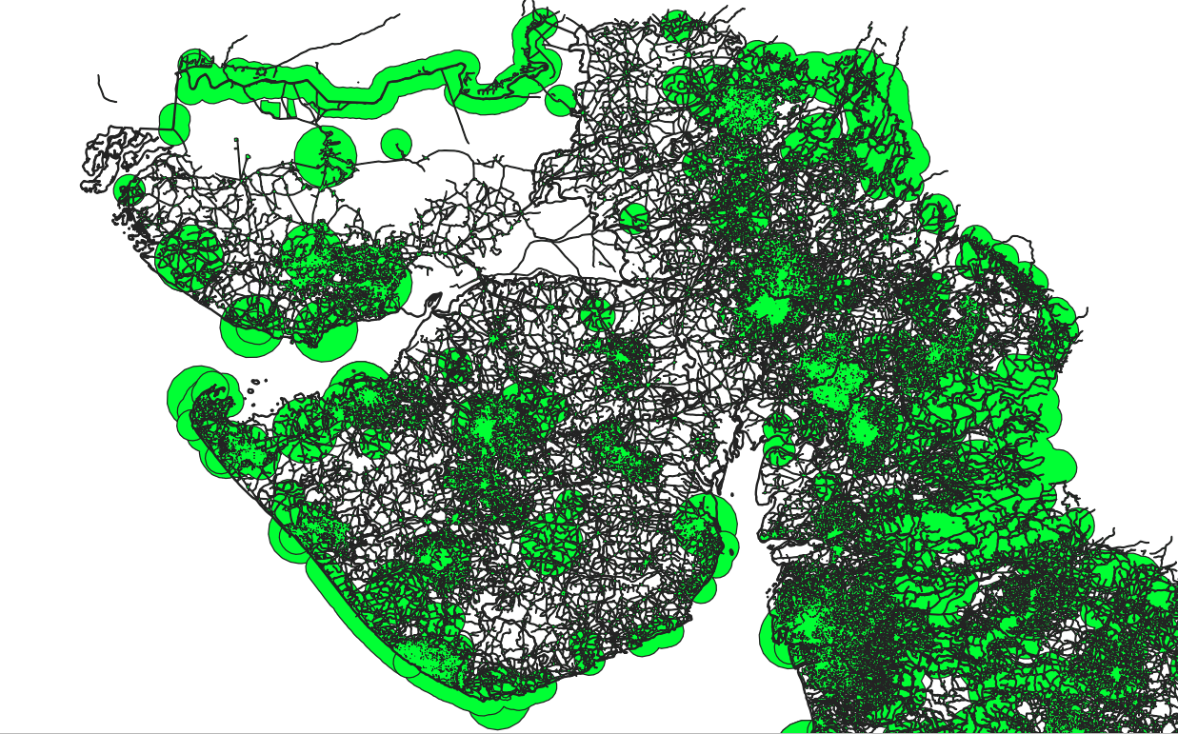

Figure 6. 1 Merged no-go area

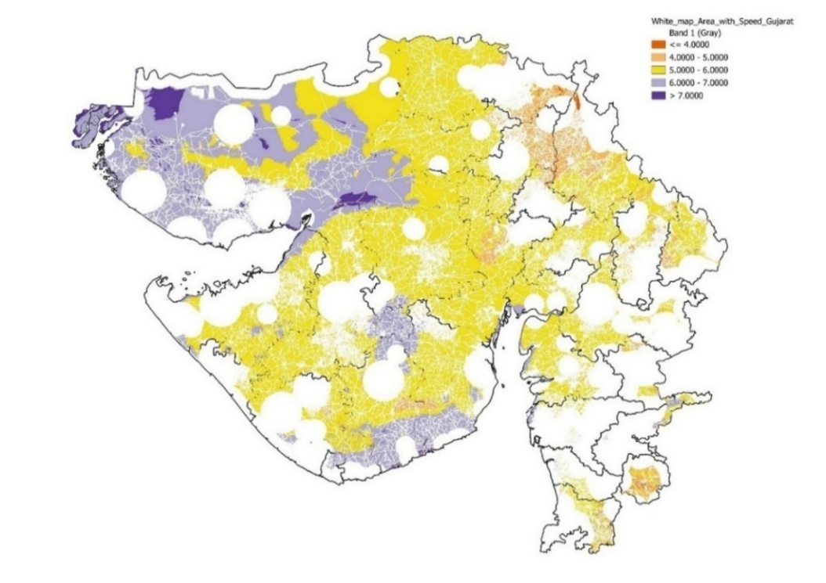

Figure 6. 2 The merged wind speed into white map

**Step 6: Integrate Wind Speed Data**

Integrated wind speed data onto the White Map layer [See Fig. 6.2], which have done by used of the Clip Raster by Mask Layer tool.

### 6.1.2 Steps Involved in the Earth Pro:

Google Earth Pro was utilized for a comprehensive site assessment. First, the presence of rivers, existing wind turbines, and other features such as residential areas was checked. Second, the proximity of the site to the grid system was assessed, and potential cabling routes were evaluated. Finally, transportation facilities were examined, and information about land ownership was gathered to determine whether it is privately or government owned.

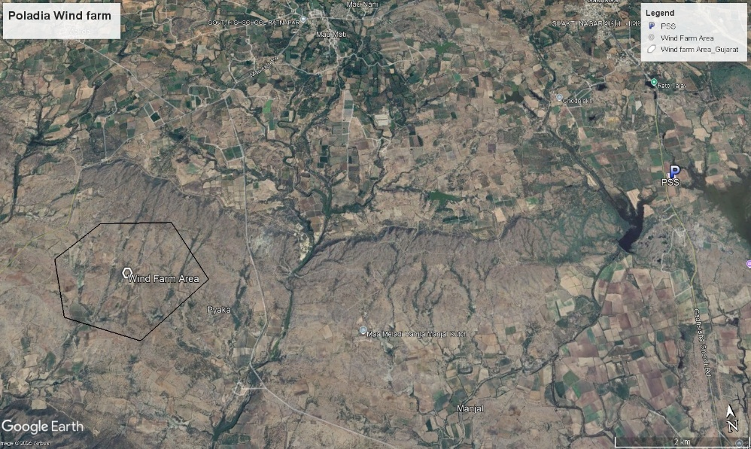

Figure 6. 3: Selected wind farm area

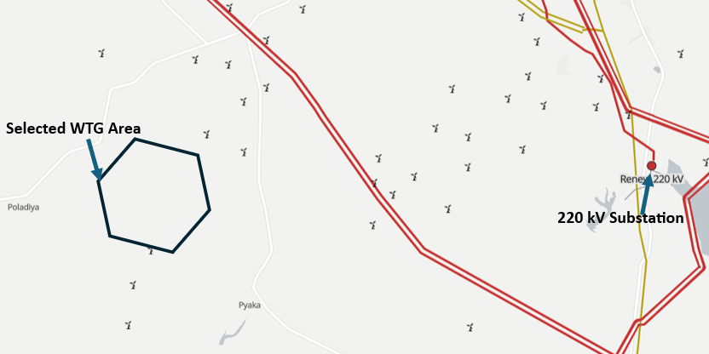

Figure 6. 4: Wind area, available substation and present installed wind turbines [16]

Site assessment was conducted using Google Earth Pro, where the land was identified as private farmland. The soil in the area is residual, characterized by a reddish-brown colour, indicating suitability for wind farm development (See Figure 6.5).

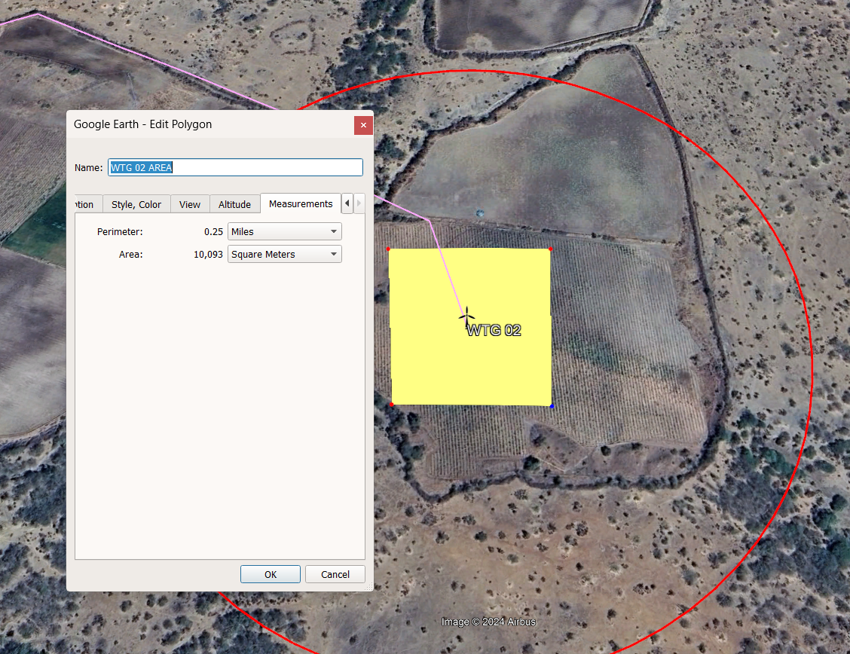

Figure 6. 5: Type of land and soil at WTG location

We also analysed the site's elevation profile, which, as shown in the figure 6.6, reveals it to be nearly flat, making it suitable for installation activities.

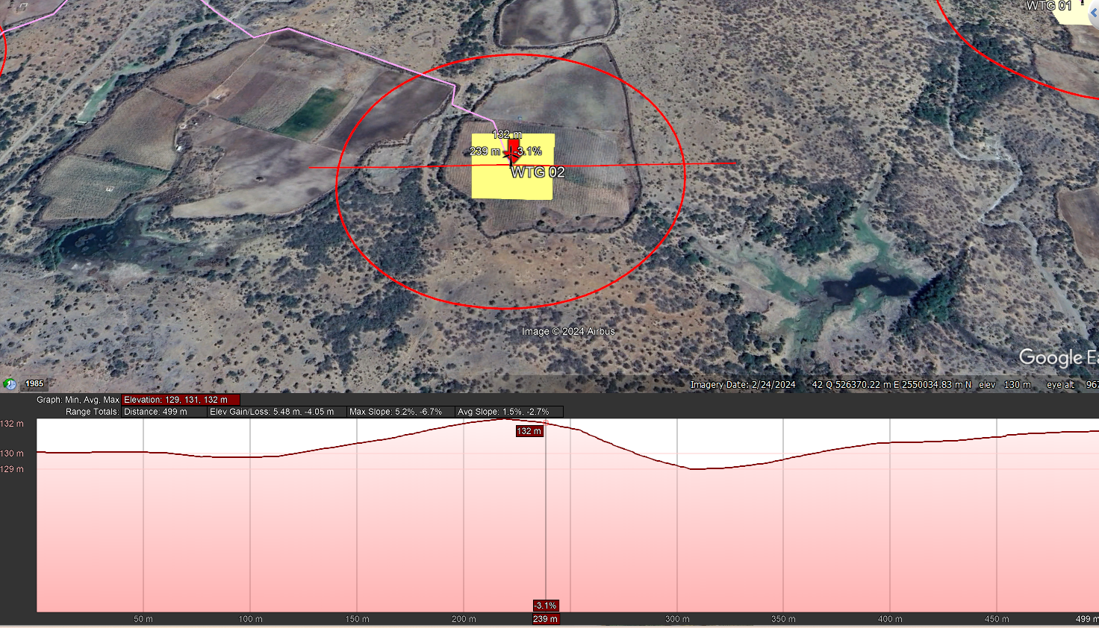

Figure 6. 6: Elevation profile in wind farm area

### 6.1.3 Steps Involved in the Wind Pro:

First, we selected the optimal wind location (Poladia, Bhuj, Gujarat, India) established the wind area boundary. Next, we chose six Suzlon **2.1 MW** wind turbines, strategically positioning them to account for wind direction (See Fig 6.7) and wake effects. Finally, we created an energy yield report to assess the project's potential energy production.

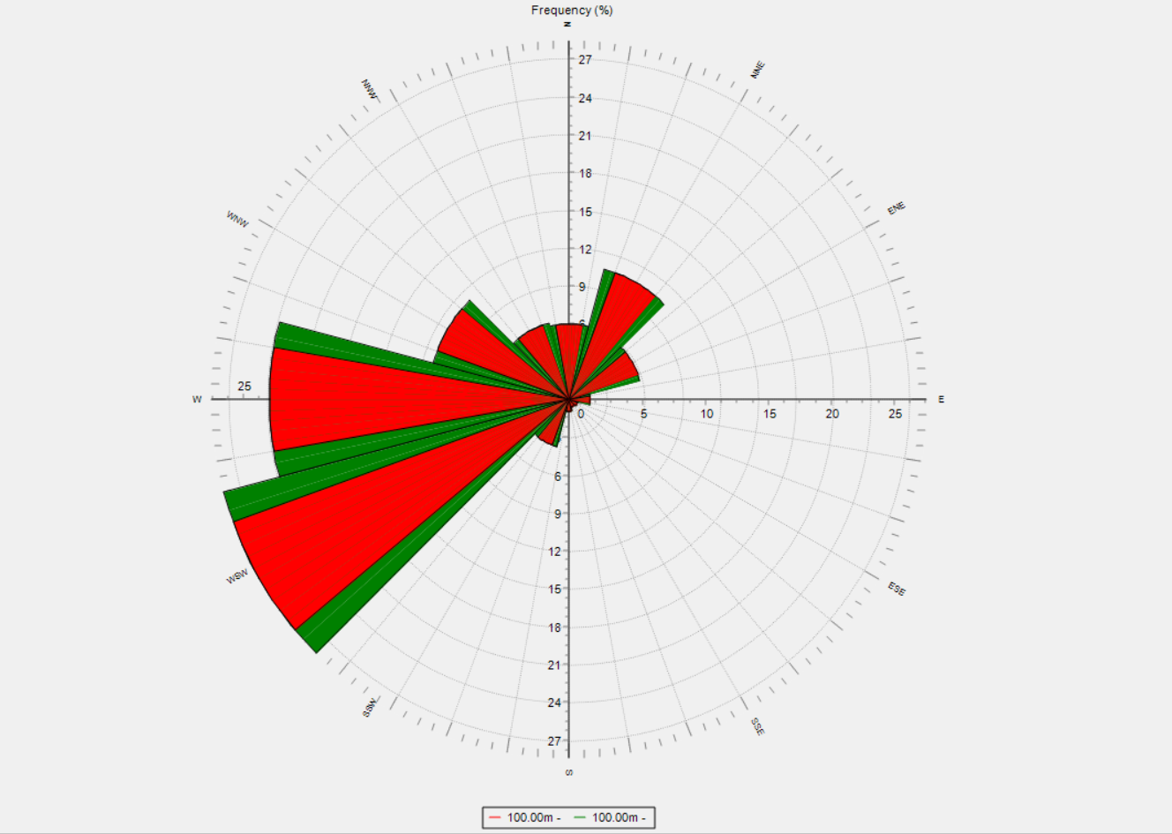

Figure 6. 7 Wind rose

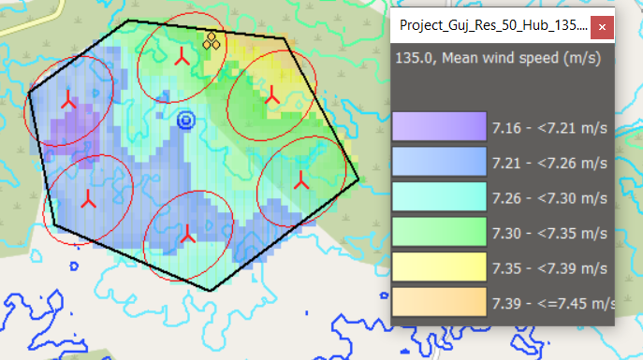

Figure 6. 8 Wind farm area with wind turbine

## 6.2 Electrical Grid Infrastructure and Cable Routing: Ensuring Connectivity

Our wind farm has a capacity of **12.6 MW**, which is relatively below 20 MW. Therefore, we utilized an available substation. The substation, named **Renew Wind Energy (AP2) Pvt Ltd**, operates at **33/220 kV**. The length of the **33 kV** internal line is **4.40 km**, whereas line from the wind farm area to the pooling substation is **16 km**, as shown in the figure 6.9. We adopted the strategy of aligning transmission lines along existing roads to minimize conflicts and simplify the permission process.

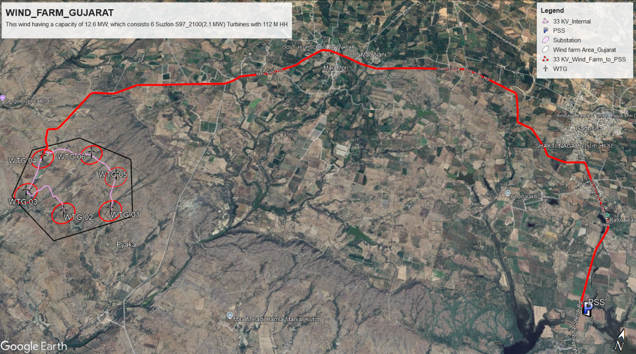

Figure 6. 9: Substation and Cable routing plan

## 6.3 Turbine Components: Logistics and Transformation

There are four locations: Daman, Vadodara, Gandhidham, and Bhuj (refer to Figure 6.7). Previously, we have selected a wind farm site located in Poladia, Gujarat, India. We had discussed that we chose Suzlon company wind turbines because they are manufactured in Gujarat, India. One of the key advantages is the ease of transportation. The government provides incentives if we select “Made in India” products, it is second key advantages.

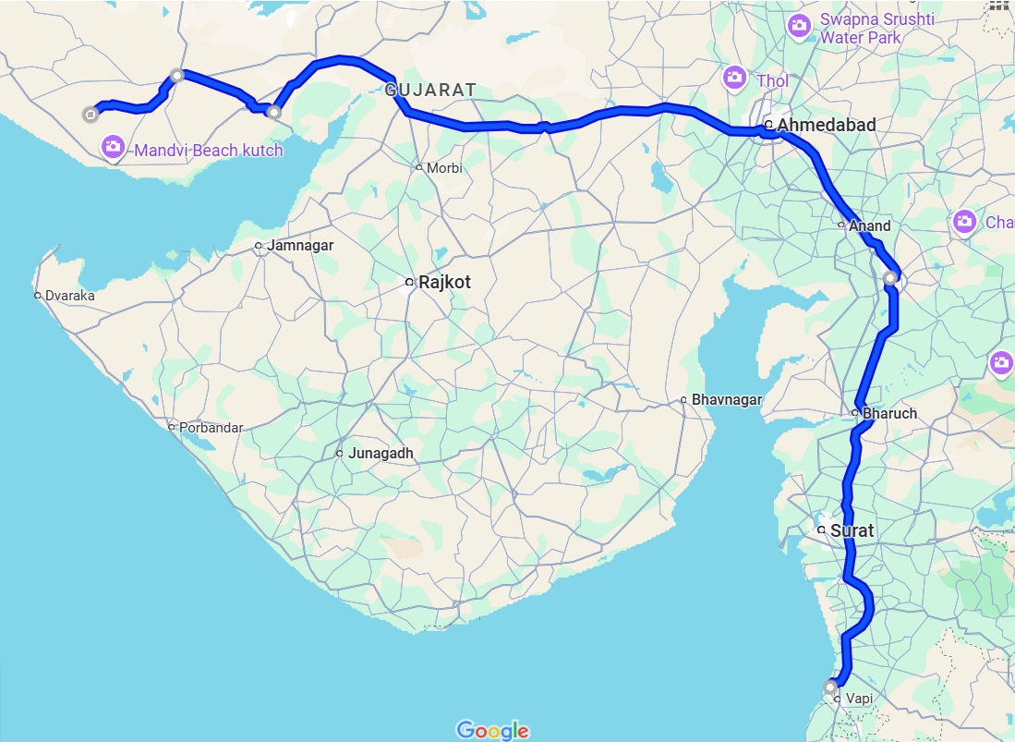

NH48

1

2

NH64

NH27

4

3

754k

NE1

NE4

Figure 6. 10: Routes for transporting wind turbine components

You can see Table 6.2, which shows the different turbine component manufacturing locations and the distances to the wind farm. Additionally, in Figure 6.7 and 6.8, the National Highway (NH), National Express Highway (NE), and Sub National Highway (754K) are represented. These are the best routes for transporting wind turbine components

|  |  |  |
| --- | --- | --- |
| Wind Turbine Manufacturing components | Manufacturing Locations | Distance between Manufacturing location to Wind farm [km] |
| Nacelle | Daman, Gujarat, India | 743 |
| Nacelle Cover | Daman, Gujarat, India | 743 |
| Hub | Daman, Gujarat, India | 743 |
| Rotor Blades | Bhuj, Gujarat, India | 57 |
| Tower | Gandhidham, Gujarat, India | 136 |
| Electrical | Vadodara, India | 544 |

Table 6. 2: Suzlon wind turbine manufacturing component’s locations and distance from wind farm [17]

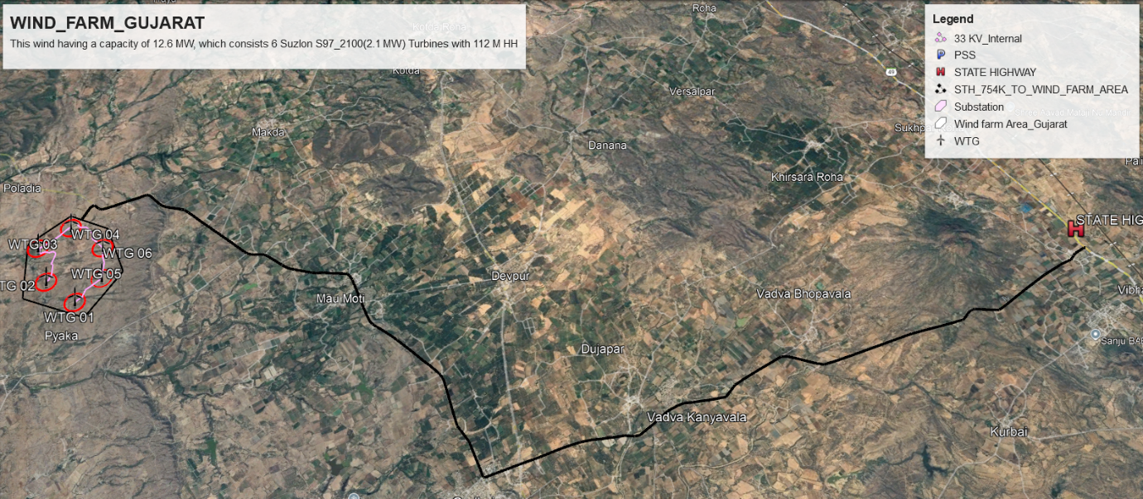

Figure 6. 11: Routes for transporting wind turbine components from Highway to Wind Farm Area

**Transportation Guidelines for Wind Turbine Components in India:**

The Ministry of Road Transport and Highways issued amendments to Rule-93 under the Central Motor Vehicle Rules 1989 to standardize vehicle dimensions in alignment with international standards. These updates aim to improve logistics efficiency, accommodating larger loads or extra passengers while adhering to weight limits. Key regulations include:

* Extendable trailers up to 50 meters are permitted for transporting exceptionally long goods, such as wind turbine blades.
* Road trains with lengths up to 25.25 meters are allowed on select routes.
* Height limits for goods vehicles (N category) increased to 4.0 meters, except smaller utility vehicles (N1), capped at 3.0 meters.
* Trailer lengths extended to 18.75 meters and heights up to 4.52 meters for ISO containers.
* Special allowances include 200 mm lateral projections for loads and a maximum vehicle height of 4.75 meters for indivisible loads like construction equipment or wind turbine components.

These provisions enhance transport options for oversized wind turbine components while ensuring safety and compliance.**Invalid source specified.**

## 6.4 Biodiversity Impact:

Gujarat has an unrivalled diversity of eco-systems reflected in the rich and varied birdlife of the state. Ranging geographically from the moist forested hills of Dangs district in the south-east to the salt-encrusted desert plains of Kutch district to the north-west.

A large percentage of the world population of Demoiselle and Common Cranes winters in Gujarat. Congregations of resident and winter-visiting ducks, geese and waders at lakes, marshes, coastal creeks and estuaries of Gujarat can be seen in vast numbers in winter. At the wetlands, huge flocks of flamingos, pelicans, storks, ibis, geese, ducks and other birds can be seen

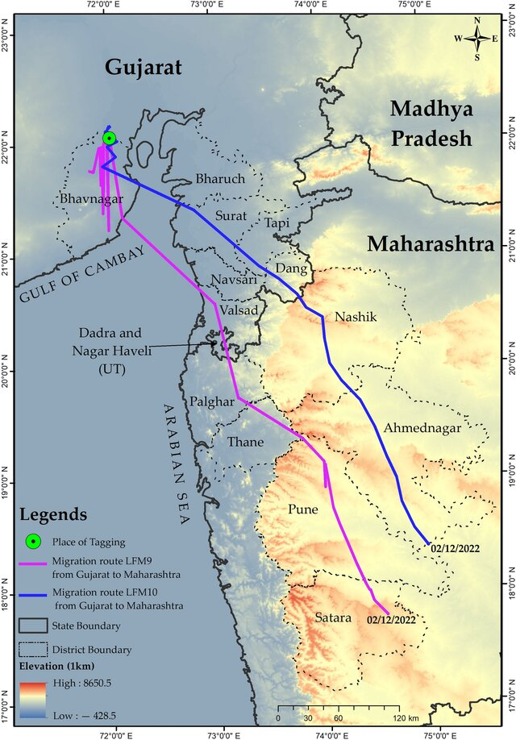

Figure 6. 12: The flight corridor of lesser floricans in Gujarat **Invalid source specified.**

Gujarat has important habitats of critically-endangered White-backed and Long-billed Vultures. About half the world population of the endangered Lesser Florican breeds at the grasslands of Saurashtra, Kutch and Dahod district during the monsoon months. Kutch has a significant population of the endangered Great Indian Bustard, flagship of India’s bird conservation movement, with a sanctuary created to protect this species in Abdasa Taluka region. Other species likely to interest a birdwatcher visiting Gujarat are the Indian Skimmer often seen at Khijadiya Bird Sanctuary, the Stolikcza’s Bushchat that could be seen at Velavadar National Park and Great Indian Bustard Sanctuary of Kutch district, White-naped Tit in Kutch district and Sarus Cranes that breeds there. Two vulnerable species of eagle, Imperial and Greater-spotted, inhabit Gujarat in winter.

route interesting for birdwatchers is the road from Jamnagar to Dwarka with reservoirs located off the highway like Sinhan and Khambaliya that are excellent for cranes, ducks, pratincoles, plovers and other birds. **Invalid source specified.Invalid source specified.Invalid source specified.**

The figure 6.12 represents the flight corridor of the migration route of lesser floricans, from their breeding range in Gujarat to their non-breeding range in Maharashtra.

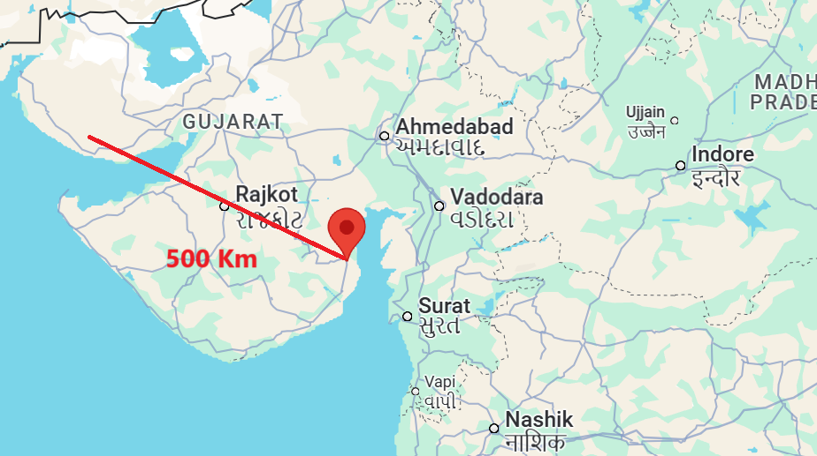

Figure 6. 13: The margin distance between wind farm to the Lesser flight corridor

The figures 6.13 shows the distance between our wind farm to the lesser flight corridor. It shows we have 500 Km margin.

# Community Engagement: Strategies for Local Acceptance

In terms of persuading local people to accept the establishment of a wind farm near them, we can offer incentives such as **profit-sharing for landowners** and **improvements to infrastructure**, including roads and the power grid and **stability of the power grid**.

## 7.1 Stability of the power grid:

Power outages, especially in rural areas, are relatively common in the region. Erecting a wind farm near the village can be a promising solution for the villagers, ensuring a stable electricity supply, available 24 hours a day, 7 days a week, with no more interruptions in power.**Invalid source specified.**

Below, you can see the table of power outage schedules in the state of Gujarat, India, and its rural areas.

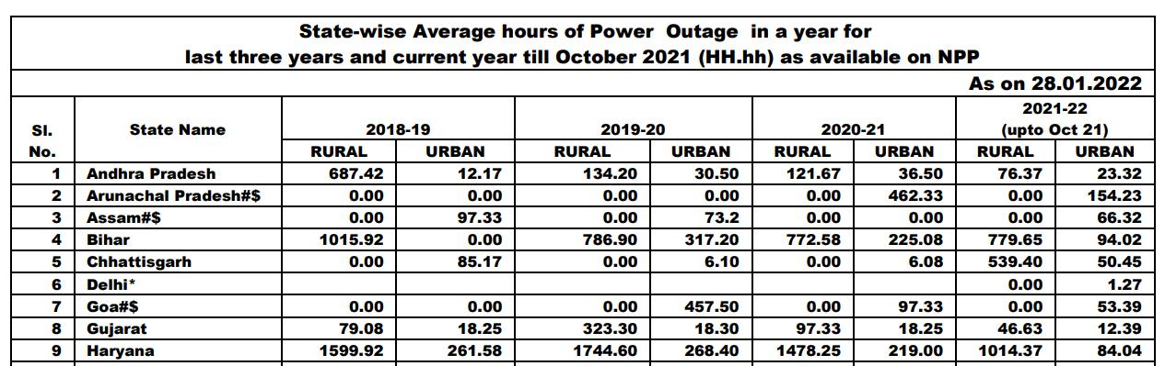

Figure 7. 1: Table of power outage schedules in the state of Gujarat, India

## 7.2 Improvement to infrastructure:

As mentioned in sections 6.2 and 6.3, the establishment of the wind park at the designated location will require the construction of a 25-kilometer road from the highway to the wind park site for transporting turbine components. This newly constructed road will also improve the village’s access to the highway, significantly enhancing the village’s infrastructure and contributing to its development. Therefore, this can serve as a highly attractive incentive for the villagers.

## 7.3 profit-sharing for landowners:

Direct profit from the project can be one of the most effective incentives for local people to accept the project. Since the proposed site for the wind farm is privately owned and will cover land belonging to many villagers, a significant number of them will benefit directly and tangibly from the project. This, in turn, increases the likelihood of the project's acceptance. The table below displays our proposed rates, including a fixed amount and a flexible amount.

**Fixed amount + Flexible amount + Agricultural losses compensation**

|  |  |  |  |  |
| --- | --- | --- | --- | --- |
| Number of owners | Area ( $m^{2}$) | Financial by rule (1/year) | Bonus  (1/year) | Total  (per year) |
| 1 (WTG) | $$100 x 100$$ | € 2050 | € 921 | € 2971 |
| 2 (WTG) | $$100 x 100$$ | € 2050 | € 921 | € 2971 |
| 3 (WTG) | $$100 x 100$$ | € 2050 | € 921 | € 2971 |
| 4 (WTG) | $$100 x 100$$ | € 2050 | € 921 | € 2971 |
| 5 (WTG) | $$100 x 100$$ | € 2050 | € 921 | € 2971 |
| 6 (WTG) | $$100 x 100$$ | € 2050 | € 921 | € 2971 |
| 7 (transmission line) | $$20 x 1000$$ | € 4100 | € 921 | € 2971 |

Table 7. 1: The proposed rates, including a fixed amount and a flexible amount

## 7.4 General strategies:

There are also general strategies to increase the acceptance rate of the project among the locals, which are as follows:

**Community Meetings**:

Organize meetings with community members to explain the benefits of the project, such as job creation, infrastructure development, and clean energy. Address any concerns and answer questions.

**Engage Local Leaders**:

Work with local leaders and influential community members to gain their support. Their endorsement can help in building trust and acceptance within the community.

**Transparency**:

Maintain transparency throughout the process by sharing project details, timelines, and potential impacts. This can help in building trust and reducing resistance.

**Benefit Sharing**:

Propose benefit-sharing, such as community development funds, scholarships, or infrastructure improvements, to ensure that the community also gains from the project.

**Regular Updates**:

Keep the community informed about the progress of the project through regular updates and open communication channels.

# Land Leasing and Acquisition: Securing the Site

**Policy 2023** aims to facilitate the leasing of government fallow land in Gujarat for the establishment of green hydrogen production facilities. These facilities will utilize non-conventional renewable energy sources such as solar, wind, and hybrid wind-solar energy. [18]

## 8.1 Lease Duration and Terms

* Lease Period: **40 years**
* Annual Rent: **₹15,000 (€ 150 – €170) per ${[10}^{4} m^{2}]$**  area, subject to a **15%** increase every three years.
* Advance Payment: Annual rent and applicable taxes must be paid in advance. Late payments integrate **12%** simple interest after **90 days**.
* Security Deposit: Applicants must provide a deposit equivalent to one year’s rent, a **1%** service charge, and necessary stamp duty upon land possession. [18]

## 8.2 Eligibility and Allocation

* Criteria: Includes financial stability (minimum net worth of **₹1200 crore (€130.44 million))**, experience in renewable energy generation (**minimum 500 MW**).
* Land Allocation Limits: One applicant or their partners can only lease enough land to produce **30 lakh metric tonnes ($3 x {10}^{8}$)** of green hydrogen each year. This means they can't lease more land than what is necessary for that amount of production. [18]

## 8.3 Application and Approval Process

* Pre-Feasibility Report: Applicants must submit a preliminary report demonstrating their capability to produce green hydrogen.
* Review Committees: A Committee of Experts evaluates the applications, followed by the High-Power Committee for final recommendations. [18]
* Tripartite Agreement: Upon approval, a tripartite agreement is signed between the Collector, the nodal agency (GPCL), and the applicant. [18]

### 8.3.1 Government land Approval Process:

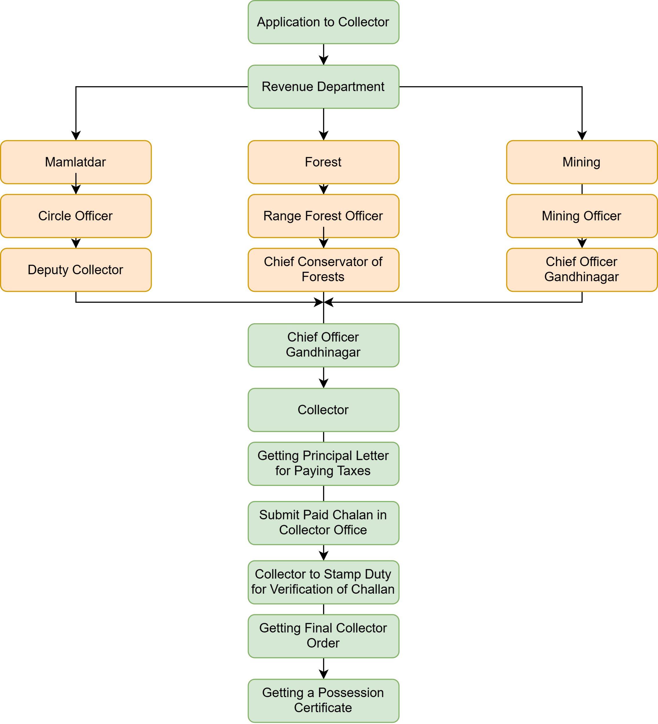

Application to collector

Figure 8. 1: Government land approval process for wind farm [13]

### 8.3.2 Private land Approval Process:

**Step 1:** Title Clearance

* The first step involves ensuring that the title of the land is clear. This includes:
* Checking all historical ownership records.
* Ensuring there are no disputes, encumbrances, or legal issues associated with the land.
* Reviewing registered documents with the Sub-Registrar's office.

**Step 2:** Agreement to Sell (ATS) and Sale Deed

* Agreement to Sell (ATS):
* The developer enters into a formal agreement with the landowner, documenting the agreed price, terms of payment, and timelines for the transaction.
* The ATS may involve an advance payment.
* Sale Deed:
* Once the terms in the ATS are fulfilled, a sale deed is executed.
* The sale deed is then registered with the Sub-Registrar’s office, completing the legal transfer of ownership to the developer.

**Step 3:** Application and Obtaining **89A** Permission from revenue department

* Purpose of **89A** Permission:
* Under Section **89A** of the Gujarat Land Revenue Code, this permission is required to formally register the land transaction.

**Step 4:** Conversion to Old Tenure Land & Payment of Premium

* Understanding Land Tenure:
* Land in Gujarat is often classified as "new tenure" (with restrictions on sale or use). Developers must convert it to "old tenure" to remove restrictions.

**Step 5**: Apply and Obtain **65 Kh** Permission (Non-Agricultural or NA Use)

**Purpose of 65 Kh Permission:**

* Land classified as agricultural must be converted to non-agricultural (NA) for setting up infrastructure like wind turbines.

**Application Process:**

* The developer applies to the District Collector or Revenue Department with relevant documents (title clearance, sale deed, and tenure conversion approval).
* The Collector grants permission, officially converting the land use to NA, allowing construction to proceed. [13]

## 8.4 Usage and Compliance

Dedicated Use: Leased land must be exclusively used for green hydrogen production.

Development Timeline: Projects must develop infrastructure and achieve 50% capacity within **3 years** and full capacity within **8 years**.

No Subleasing: The leased land cannot be subleased to third parties. [18]

## 8.5 Financial and Operational Responsibilities

Infrastructure Development: Applicants are responsible for all infrastructure, including power transmission, roads, water supply, and security.

Energy Usage: Generated renewable energy must primarily be used for green hydrogen production within Gujarat. Excess energy sales are subject to government discretion.

Charges and Taxes: All applicable taxes, licensing fees, and GST must be borne by the lease agreement. [18]

## 8.6 Governance and Oversight

Nodal Agency (GPCL): Manages land allocation, application processing, and project monitoring.

High Power Committee (HPC): Sets parameters for equipment and production standards, and prioritizes applications based on predefined criteria.

Revenue Department: Ensures land allocation aligns with state requirements and oversees final approvals. [18]

## 8.7 Provision of Land procurement/ acquisition in Gujarat Wind Power Policy 2016

The Gujarat Energy Development Agency (GEDA) will act as the State Government's Nodal Agency for implementing and facilitating the Gujarat Wind Power Policy-2016. GEDA will support project developers by assisting with the following activities to achieve the policy's objectives:

**Project Registration**: Ensuring wind power projects are properly registered.

|  |  |  |
| --- | --- | --- |
| S.No | Department | Designation |
| 1 | ACS/PS/Secretary (CCD) | Chairman |
| 2 | AS/JS/Deputy Secretory (EPD) | Member |
| 3 | Chief Electrical Inspector & Collector of Elect.  Duty | Member |
| 4 | General Manager (Comm), GUVNL | Member |
| 5 | Respective District Collector | Member |
| 6 | Director, GEDA | Member Secretary |

Table 8. 1: Project registration [19]

**Developer Assistance**: Addressing queries and resolving issues faced by wind power project developers.

**Accreditation**: Facilitating the accreditation and recommending wind power projects for registration with the Central Agency under the Renewable Energy Certificate (REC) mechanism.

Wind Turbine Generators (WTGs) can be established on private land, revenue wasteland allotted by the State Government, or land owned by GEDA (if available). The allocation of GEDA-owned land on lease requires the approval of a Coordination Committee, as detailed in the policy's framework. Additionally, this committee is responsible for resolving issues beyond land allotment, such as interpreting specific provisions of the policy.

# Addressing Conflicting Interests

|  |  |  |  |  |  |  |  |  |  |  |  |  |  |
| --- | --- | --- | --- | --- | --- | --- | --- | --- | --- | --- | --- | --- | --- |
| **Impact** | **PYSICAL ENVIRONMENT** | | | | | | | | **SOCIO-ECONOMIC ENVIRONMENT** | | | | |
| **Activity** | **Visual Aesthetics** | **Topography** | **Air Quality** | **Noice Impact** | **Ground water Quality** | **Soil removes** | **Land use** | **Ground water Resources** | **Loss of land** | **Common Property usage /conflict** | **Community health** | **Cultural Heritage** | **Occupational Health & Safety** |
| Sourcing  And transportation of construction material etc. | L |  | M | L |  | L |  |  |  | L | L |  | M |
| Storage and handling of raw material | L |  | L |  | L | L | L |  |  |  | L |  | M |
| Establishment of labour camp and hiring of labour | L |  | L | L |  | L |  |  |  |  |  |  |  |
| Access road construction | M |  | L | L |  |  |  |  | L |  | L |  | L |
| Site clearance | M |  | L | L |  | L |  |  |  |  |  |  | L |
| Foundation excavation | M |  | L | L |  |  |  |  |  |  |  |  | M |
| Transportation of WTG components to site and storage | M |  | L | L |  |  |  |  |  |  | L |  | M |
| Erection of WTG’s | M | M | L | L |  |  | M | L |  |  |  |  | M |
| Transformer yard construction | M |  | L | L |  |  |  | L |  |  |  |  | M |
| Laying of transmission lines | M |  | L | L |  |  |  |  | M |  | L |  | M |
| Periodic maintenance of all WTG’s at every location |  |  |  |  |  |  |  |  |  |  |  |  | M |
| Maintenance of ancillary facilities such as Store, yard, site office, transmission lines |  |  |  |  |  |  |  |  |  |  |  |  | M |
| Security of WTG’s in operation |  |  |  |  |  |  |  |  |  |  | L |  | M |
| Operation of Wind Turbine |  | M |  |  |  |  |  |  |  |  | L |  |  |

L = Low, M = Medium, H = High [13]

Table 9. 1: Addressing Conflicting Interest

# 10. Economic analysis

## 10.1 Profitability Analysis: Calculating the Financial Viability

**Income:**

|  |  |  |
| --- | --- | --- |
|  | $$Income=Net energy yield \left(kwh\right) ∙Feed in tariff \left(\frac{Euro}{kWh}\right)$$ | (10. 1) |
|  | $$Income=39924500 ∙0.033 =1,290,000 €$$ | (10. 2) |

**Operating costs:**

|  |  |  |
| --- | --- | --- |
|  | $$Oprating costs=Total operating costs \left(Euro\right)∙Inflation$$ | (10. 3) |
|  | $$Oprating costs=1,05,000 \left(€\right)∙last year infation ∙(1+inflation)$$ | (10. 4) |

Inflation: **5.16 %** (for last 10-year average rate)

The total operating cost encompasses a full maintenance contract, lease costs, financial statements, tax advice, insurance, and operational management. It also includes dismantling guarantee reserves, own consumption, miscellaneous expenses, and agricultural impacts like hamster management and yield loss compensation for farmers growing wheat and barley.

**EBITDA: Earnings before Interest, Taxes, Depreciation and Amortization:**

|  |  |  |
| --- | --- | --- |
|  | $$EBITDA=Income -Operating Costs$$ | (10. 5) |

**Depreciation and Amortization:**

|  |  |  |
| --- | --- | --- |
|  | $$Depreciation and Amortization= \frac{Total Investment costs}{Depreciation period}$$ | (10. 6) |

$$= \frac{98,07,253 Euro}{14 Years}$$

It refers to the reduction in the value of an asset over time, typically due to wear and tear, usage, or obsolescence. We have considered value of **7,00,518 euro** until 14 years.

**EBIT: Earnings before Interest and Taxes:**

|  |  |  |
| --- | --- | --- |
|  | $$EBIT=EBITDA-Depreciation and Amortization$$ | (10. 7) |

**Net Financial Income:**

|  |  |
| --- | --- |
| $$Net financial income=\frac{Opening Balance-Repayment}{2}∙Interest rate$$ | (10. 8) |

|  |  |  |
| --- | --- | --- |
|  |  | (10. 9) |
|  | $$Equity=Total inverstment cost ∙(1-Debt ratio)$$ | (10.10) |

Here,

Debt ratio = **72.73%**, Total investment cost = Total purchase price = **98,07,253 $€$** , Repayment = **4,19,584 $€$** , Interest rate = **9 %**

**EBT: Earnings before Taxes:**

|  |  |  |
| --- | --- | --- |
|  | $$EBT=EBIT+Net financial income$$ | (10. 11) |

$CITATION Arj24 \backslash l 16393 [20]$ [21] [22] [23] [24]

|  |  |  |
| --- | --- | --- |
| Parameter | Economics | Unit |
| Number of WT | 6 | - |
| Installation output | 2100 | KW |
| Total output | 12600 | kW |
| Gross Energy Yield | 39924500 | KWh/a |
| Total losses | 2.20 | % |
| Net Energy Yield | 399,046,161 | kWh |
| Site Quality | 71.04 | % |
| Feed in Tariff | 0.033 | Euro/kWh |
| Total Investment Costs | 98,07,253 | Euro |
| Total Operating Costs | 1,05,000 | Euro |
| Constant Payment Loan Type (Debt ratio) | 72.73 | % |
| Equity | 26,74,327 | Euro |
| Term | 17 | Years |
| Interest rate of Bank | 9.0 | % |
| Debt Capital | 71,32,926 | Euro |
| Inflation rate | 5.16 | % |

Table 10. 1: Economics of A Typical Wind Farm

## 10.2 Results

The financial analysis of the project shows a strong performance with a positive NPV of **303,893** **Euro**, indicating profitability. The IRR of **8.730%** demonstrates a return on investment, while the LEC of **0.0179 Euro** confirms cost-efficient energy production. The project shows solid financial stability with a minimum DSCR of **1.11** and an average DSCR of **1.40**, ensuring the capability to meet debt obligations. Although the NPV costs are **2,542,246 Euro**, the substantial NPV kWh value of **404,782,498 Euro** highlights significant revenue generation from energy production. Overall, the metrics suggest the profitable project.

|  |  |  |
| --- | --- | --- |
|  | Value | Unit |
| NPV | 303,893 | EUR |
| NPV costs | 2,542,246 | EUR |
| NPV kWh | 404,782,498 | EUR |
| IRR | 8.730 | % |
| LEC | 0.0179 | EUR |
| Min. DSCR | 1.11 |  |
| ADSCR | 1.40 |  |

Table 10. 2: Results

# 11. Project Development Timeline

The project development timeline for establishing a wind farm in Gujarat, from greenfield to operation, approximately **5 to 9 years**. It begins with a thorough study of relevant laws and regulations, taking around **2 to 6 months**. This is followed by site assessment, lasting **12 to 15 months**, to evaluate the suitability of potential locations. Land leasing negotiations, which take about **4 to 7 months**, secure the necessary plots for the project. Next comes the planning phase, extending over **18 to 30 months**, where detailed project designs are formulated. Permitting processes occur concurrently, spanning **6 to 12 months**, to obtain the required legal approvals. Securing financing, which also takes **6 to 12 months**, ensures the project has the necessary funds. The construction phase, lasting **12 to 20 months**, involves the physical setup of the wind farm infrastructure. Finally, the commissioning phase, taking **3 to 6 months**, ensures the wind farm is fully operational and integrated into the grid. [19]

|  |  |  |
| --- | --- | --- |
| Phases | Descriptions | Timeline |
| 1 | Study Laws and Regulations | 2 – 6 months |
| 2 | Site Assessment | 12 – 15 months |
| 3 | Land Leasing | 4 – 7 months |
| 4 | Planning | 18 – 30 months |
| 5 | Permitting | 6 – 12 months |
| 6 | Financing | 6 – 12 months |
| 7 | Constructions | 12 – 20 months |
| 8 | Commissioning | 3 – 6 months |
| 9 | Operations | 20 – 25 years |

Table 11. 1: Project development timeline [19]

By conducting the first two processes in parallel, followed by the next four processes together, and then the final two processes sequentially, the timeline is optimized to reduce delays and accelerate the project's completion. With these optimizations, the overall timeline can be reduced to approximately **3.5 to 5 years**, ensuring a more efficient and effective project development process.

# 12. Barriers and Obstacles to Wind Farm Development

**Land Use Conflicts**: There are a total of seven landowners for the wind farm. It is important to talk with all the owners and convince them of the benefits of wind farm development, although this can sometimes be challenging.

**Maintenance Issues:** Maintenance and servicing of wind turbines in Gujarat face significant challenges due to extreme weather conditions. Summers often reach temperatures as high as 45°C, while harsh monsoon seasons bring heavy rainfall and high humidity, both of which can impact equipment performance and complicate maintenance activities.

**Grid Integration**: Integrating wind energy into the existing power grid can be challenging due to the need for stable and reliable energy supply.

**Limited Awareness:** Low awareness among potential users and stakeholders about the benefits and applications of wind turbine.

**Low Energy Price:** The present energy price is **0.033 euro/kWh**, which is very low. This benefits for customers, but disadvantages for investors because they receive less profit from the project.

**High Bank Tax Rate:** The present bank tax rate is **9%,** which is very high for investors. Investors spend more money into paying bank taxes, comparing to getting benefit from project.

**Preference for Solar Energy:** Higher preference for solar energy over wind energy due to various factors such as, low CAPEX, government supports. [25] [26]

# 13. Long-term Strategy: Wind Energy Development Roadmap to 2030/2050

The state of Gujarat has good potential for wind energy development, which can significantly contribute to India's renewable energy goals.

**Vision and Goals:**

**By 2030:**

**Vision of India:**

* Achieve an install renewable energy capacity of **500 GW**.
* From them **140 GW (28%)** will be Wind energy production.

**Vision of Gujarat:**

* Achieve an installed renewable energy capacity of **128.6 GW**.
* Increase the share of wind energy to **24%** of the state's total energy mix.
* Launch the first phase of offshore wind projects. [8]

**By 2050:**

* Establish Gujarat as a global leader in wind energy.
* Fully integrate smart grid solutions for efficient energy distribution.
* Achieve a **50%** reduction in carbon emissions from energy production. [8]

**Strategy for achieving goal:**

To achieve long-term wind energy goals, Gujarat will improve policy support, adopt advanced turbine technologies, and upgrade infrastructure. By integrating smart grids and encouraging community engagement, the state aims to significantly reduce carbon emissions. Government and company will spend more money in research and development of wind turbine and energy storage system. This comprehensive approach ensures sustainable and efficient wind energy development, positioning Gujarat as a leader in renewable energy.

# 14. Conclusion:

The Poladia wind farm project represents a significant step in renewable energy development, Taking advantage of Gujarat’s favourable policy environment and advanced Suzlon technology. By focusing on efficient and reliable turbines, the project achieves a positive NPV and an impressive IRR, indicating strong financial viability. However, the project faces significant challenges due to high bank tax rates and low energy prices, which reduce its overall profitability. Increasing capital investment could enhance project benefits, while alternatives such as raising energy prices or seeking government support for loans could also improve financial outcomes.

The project contributes to India's net-zero goals by reducing carbon emissions and promoting sustainable development. It also drives economic progress through job creation and local manufacturing, aligning with the "Aatmanirbhar Bharat" initiative.

In the long-term, the Poladia wind farm sets a benchmark for sustainable energy development, supporting India's transition to a greener economy and contributing to global sustainability efforts.

# References

|  |  |
| --- | --- |
| [1] | “MINISTRY OF NEW AND RENEWABLE ENERGY,” 01 2024. [Online]. Available: https://mnre.gov.in/wind-overview. [Accessed 2024 10 02]. |
| [2] | “A Deep Dive into Wind Energy Farms in India: Tapping into the Power of the Breeze,” Green Energy, 23 01 2024. [Online]. Available: https://powerefficiency.com/wind-energy-farms-in-india/. [Accessed 02 10 2024]. |
| [3] | NATIONAL INSTITUTE OF WIND ENERGY, “India’s Wind Potential Atlas,” UNDER MINISTRY OF NEW AND RENEWABLE ENERGY, GOVERNMENT OF INDIA, Chennai, 2019. |
| [4] | “gujarat-bags-award-for-highest-wind-power-installed-capacity,” thehindubusinessline, 15 06 2024. [Online]. Available: https://www.thehindubusinessline.com. [Accessed 2 10 2024]. |
| [5] | A. P. Z. P. C. Draxl, “Wind Resource Assessment,” NREL National Renewable Energy Laboratory, July, 2014. |
| [6] | M. Gupta, “Scaling Challenges In Gujarat: Adani’s 300 MW Wind Farm Project And Its Journey Through Regulatory And Logistical Hurdles,” WINDINSIDER EMPOWERING THE WIND SECTOR, 13 05 2024. [Online]. Available: https://windinsider.com. [Accessed 10 10 2024]. |
| [7] | Suzlon Group, “Suzlon secures a repeat order of 193.2 MW from The KP Group in Gujarat,” 21 December 2023. [Online]. Available: https://www.suzlon.com. [Accessed 13 10 2024]. |
| [8] | MINISTRY OF NEW AND RENEWABLE ENERGY, “Clarification to the ‘Guidelines for Development of Onshore Wind Power Projects’ and amendments,” Government of India, 18 12 2024. [Online]. Available: https://mnre.gov.in/en/document/clarification-to-the-guidelines-for-development-of-onshore-wind-power-projects-and-amendments/. [Accessed 15 11 2024]. |
| [9] | thc.nic.in, “THE HAZARDOUS WASTES (MANAGEHANDLING AND TRANSBOUNDARY MOVEMENT) RULES, 2008,” Official Gazeette, MARCH, 2010. |
| [10] | Forest Clearance, “Forest Conservation Rules,” 2003. [Online]. Available: https://forestsclearance.nic.in. [Accessed 17.11.2024]. |
| [11] | National Board for Wildlife, Ministry of Environment and Forest, India, “Guidelines for linear infrastructure intrusions in natural areas: roads and powerlines,” 10 Octomber 2011. [Online]. Available: https://moef.gov.in. [Accessed 25 11 2024]. |
| [12] | India Air Force, “GUIDELINES FOR ISSUE OF NOC FOR CONSTRUCTIONS AROUND INDIAN AIR FORCE AERODROMES,” 12 2021. [Online]. Available: https://indianairforce.nic.in. [Accessed 11 11 2024]. |
| [13] | ARCADIS India Pvt. Ltd., “ENVIRONMENTAL & SOCIAL IMPACT ASSESSMENT: 250 MW Wind Power Project in Kutch district, Gujarat,” ARCADIS, Kutch, 2017. |
| [14] | DTU, “GLOBAL WIND ATLAS,” DTU, ESMAP, WORLD BANK GROUP, VORTEX, [Online]. Available: https://globalwindatlas.info. [Accessed 24 11 2024]. |
| [15] | GEOFABRIK, “OpenStreetMap Data Extracts,” [Online]. Available: https://download.geofabrik.de/. [Accessed 25 11 2024]. |
| [16] | Openinframap, [Online]. Available: openinframap.org. [Accessed 26 12 2024]. |
| [17] | suzlon, “supply-chain-management-and-manufacturing,” 2024. [Online]. Available: https://www.suzlon.com. [Accessed 12 12 2024]. |
| [18] | Government of Gujarat, “Policy-2023 for leasing the government fallow land for green hydrogen production using non-conventional energy sources such as solar, wind, wind solar hybrid energy.,” 08 May 2023. [Online]. Available: https://www.eqmagpro.com. [Accessed 13 10 2024]. |
| [19] | Gujarat Goverment , “policy_files,” 2016. [Online]. Available: https://geda.gujarat.gov.in. [Accessed 28 11 2024]. |
| [20] | A. Joshi, “Gujarat Sets ₹2.84/kWh Tariff for wind projects below 10 MW comnnissioned by 2027,” MERCOM Clean Energy Insights, 04 09 2024. [Online]. Available: https://www.mercomindia.com. [Accessed 25 12 2024]. |
| [21] | Macrotrends, “India Inflation Rate 1960-2024,” Macrotrends LLC, [Online]. Available: https://www.macrotrends.net. [Accessed 25 12 2024]. |
| [22] | U. Ehlers, *Project financing in the wind power sector (Lecture Note),* Flensburg, Germany: Hochschule Flensburg Prof. Marina Blohm, 20.11.2024. |
| [23] | EI News Network, “GERC Updates Regulations for Small Wind Projects,” energetica INDIA, 05 September 2024. [Online]. Available: https://www.energetica-india.net. [Accessed 27 12 2024]. |
| [24] | iNDEXTb/GM(Project&Tech.), “Wind Farm - An Opportunity for Investment in Gujarat,” Goverment of Gujarat, Gandhinagar. |
| [25] | M. B. Arshi Banu P S, “Wind energy feasibility and wind turbine selection studies for the city Surat, India,” *Clean Energy,* vol. 8, no. 3, pp. 166-173, 2024. |
| [26] | L. C. a. A. B. Vaisakh Suresh Kumar, “Scaling up small wind turbines in India (Barriers and options for the way forward),” WRI-INDIA.ORG and CLEAN , Delhi, 2024. |
| [27] | A. P. a. Z. P. . Draxl, “Wind Resource Assessment,” National Renewable Energy Laboratory (NREL), 2014. |
| [28] | R. m. https://www.mercomindia.com/gujarat-land-policy-solar-wind-projects, “Gujarat's New Land Policy for Solar, Wind Projects to Make Developers More Accountable,” MERCOM, Clean Energy Insights, 17 September 2020. [Online]. Available: https://www.mercomindia.com/gujarat-land-policy-solar-wind-projects. [Accessed 05 10 2024]. |
| [29] | D. M. Blohm, *Lecture Notes on Wind Farm Development,* Flensburg, 2024. |
| [30] | EU-INDIA CLEAN ENERGY & CLIMATE PARTNERSHIP, “About the partnership,” European Union , 30 March 2016. [Online]. Available: https://www.cecp-eu.in. [Accessed 13 10 2024]. |
| [31] | Nature India, “Is the drive for clean energy throwing environmental caution to the wind?,” *NEWS FEATURE,* 16 June 2019. |
| [32] | P. C. Abhishek Gawande, “Environmental and social impacts of wind energy: a view point with reference to India,” Indian Institute of Forest Management, Bhopa, 2019. |
| [33] | Gujarat Urja Vikas Nigam Ltd, “REQUEST FOR SELECTION (RfS),” 10 07 2023. [Online]. Available: https://jmkresearch.com. [Accessed 20 10 2024]. |
| [34] | V. Shah, “India Sets Sail on 1 GW Offshore Wind Energy Projects in Gujarat, Tamil Nadu,” goodreturns, 19 June 2024. [Online]. Available: https://www.goodreturns.in. [Accessed 22 10 2024]. |
| [35] | Editorial Team, “Gujarat: Pioneering Sustainable Wind Power Generation in India,” SSMB.IN, 19 September 2024. [Online]. Available: https://ssmb.in/2024/09/19/gujarat-pioneering-sustainable-wind-power-generation-in-india/. [Accessed 22 10 2024]. |
| [36] | GE VERNOVA, “GE acquires 49% stake in Continuum onshore wind farm in support of the energy transition in India,” GE, [Online]. Available: https://www.gevernova.com. [Accessed 22 10 2024]. |
| [37] | Gujarat Energy Development Agency, Gujarat Government, [Online]. Available: https://geda.gujarat.gov.in. [Accessed 22 10 2024]. |
| [38] | Wind farm BoP, “Wind farm testing and commissioning,” 2017, [Online]. Available: https://www.windfarmbop.com/. [Accessed 22 10 2024]. |

# Appendices

## Park Calculation Report:

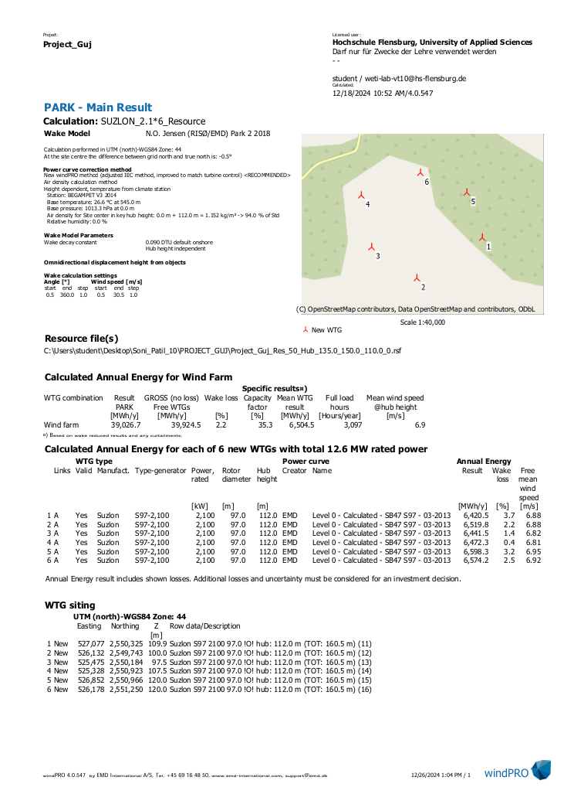

## Income Statement of the Wind Farm Project:

|  |  |
| --- | --- |
| Years | Profit after tax (Euro) |
| 2025 | -314,377 |
| 2026 | -320,076 |
| 2027 | -326,069 |
| 2028 | -163,490 |
| 2029 | -132,354 |
| 2030 | -101,561 |
| 2031 | -71,128 |
| 2032 | -41,073 |
| 2033 | -11,824 |
| 2034 | 17,824 |
| 2035 | 46,623 |
| 2036 | 74,960 |
| 2037 | 102,810 |
| 2038 | 130,148 |
| 2039 | 857,467 |
| 2040 | 694,104 |
| 2041 | 636,539 |
| 2042 | 654,049 |
| 2043 | 671,099 |
| 2044 | 687,664 |

## Income Vs Years:

## Operating costs (OPEX) vs Years:

## Debt service Vs Years:

## Taxes Vs Years:

## GitHub Link

What to know more about project?

Check out our GitHub;

<https://github.com/KSoni1505/Wind-Farm-Project-Development>